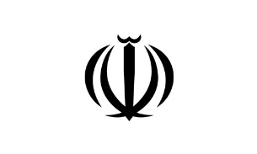

IRAN Report
«9»

We will produce 14m doses of Covid vaccine in three month - Chairman of the Headquarters for Executing Imam Khomeini’s Order (HEIKO)
“We will reach the production of 12 to 14 million doses of Covid vaccine in May and June next year [the Iranian year ends on March 20] as planned and solve the problem of producing this vaccine,” Mohammad Mokhber, Chairman of HEIKO said.
The official said the interim trial data showed no side effects and the vaccine, named Coviran Barekat, is effective on the Covid-19 mutations identified in Britain and South Africa.
http://www.isna.ir/news/99103021844

Human testing approved for 2nd Iranian COVID-19 vaccine
Human testing for Iran’s second experimental vaccine developed by Razi Vaccine and Serum Research Institute will begin in the near future.
Ali Es’haqi, the head of the institute, said Razi Cov Pars will be administered to the 18-55 age group in a double-blind study. While Barkat is made from a dead or weakened coronavirus, Razi has produced a protein-based vaccine that trains the body’s immune system to recognize the protein spike on the surface of SARS-Cov-2.
https://www.isna.ir/news/99102920834/

Largest gas refinery in ME goes operational in southwestern Iran
President Hassan Rouhani officially has inaugurated Persian Gulf Bid Boland Gas Refinery in southwestern Khouzestan Province through videoconference. Addressing the inauguration ceremony, President Hassan Rouhani appreciated efforts by all Iranian engineers, workers and experts involved in the project.
"This refinery is capable of collecting the whole associated gas in three provinces of Khuzestan, Kogilouyeh-Boyrahmad and Bushehr," Mahmoud Aminnejed, managing director of Bid Boland, said in the televised ceremony.
In the first phase, associated gas of the East Karun oil fields will be collected in bid to clean the environment from flare gas, Aminnejad said, and in the second one, those of the West Karun will be processed in Bid Boland. The plant is currently the third such facility in the world, he added.
http://www.irna.ir/news/84193744/
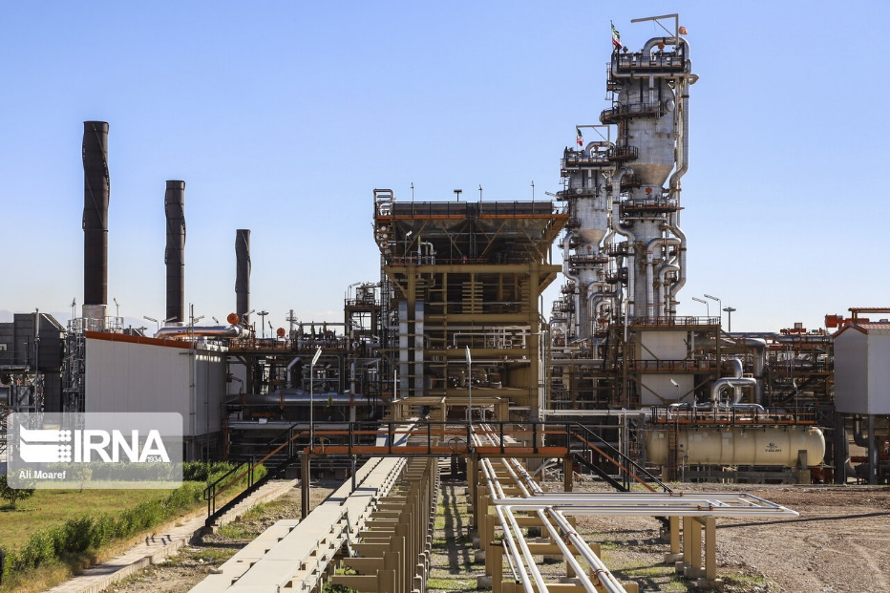
Iran, Azerbaijan agree to boost railway cooperation
Iran and the Azerbaijan Republic have agreed to connect the Baku-Astara highway to the one linking Ardabil and Rasht.
The agreement came in a meeting between Iranian Minister of Roads and Transportation Mohammad Eslami and the Azerbaijan Republic’s Deputy Prime Minister Shahin Mustafayev.
https://apa.az/az/infrastruktur/Baki-Astara-v-rdbil-Rst-magistral-yollarinin-birlsdirilmsin-dair-sazis-imzalanib-625058

Armenian minister in Tehran for economic talks
Armenian Economy Minister Vahan Kerobyan arrived in Tehran on Friday to discuss the expansion of trade ties between Armenia and Iran. During his five-day visit, he met with government and private sector officials, visited the Cinnagen and the Mihan dairy factories, and Isfahan province.
The visit of the Armenian delegation to Iran comes at a time when a delegation from Azerbaijan visited Iran to hold the 14th Joint Commission on Trade and Economic Cooperation.
https://is.gd/zFQtPX

‘Iran is biggest gasoline producer, exporter in region’
Managing director of National Iranian Oil Refining and Distribution Company (NIORDC) has said his company is currently the biggest producer and exporter of gasoline in West Asia, Shana reported.
“We are exporting to most of our neighbouring countries including Afghanistan, Pakistan, Armenia, Azerbaijan, and Iraqi Kurdistan,” Alireza Sadeq-Abadi said on the sidelines of a visit to the Iran Oil Show exhibition.
Iran has achieved this success despite the external pressures and hurdles imposed by the U.S. sanctions on the country’s oil industry, Sadeq-Abadi said.
https://www.isna.ir/news/99110402511

Trump failed to decrease Iranian oil export to zero: minister
Bijan Namdar Zanganeh, Iran’s oil minister, says that the Islamic Republic did not allow the Trump administration to decrease Iranian oil export to zero. In separate remarks, Zanganeh also said, “Trump thought we die due to the sanctions, but we did not, they are knocked down.”
https://sptnki.com/eNMZ9i

Iran and Azerbaijan expand railroad ties
Iran and Azerbaijan signed an agreement to increase cooperation during a recent meeting. According to the agreement, both sides agreed to expand their railroad cooperation with the aim of boosting cargo volume of two million tons a year and facilitate railroad developments. The volume of cargo transit between Iran and Azerbaijan increased to 480,000 tons in 2020 despite the outbreak of coronavirus.
https://mehrnews.com/xTzwn

Iranian transit and export trucks to Azerbaijan to flow
In talks with the Prime Minister of Azerbaijan, Minister of Roads and Urban Development, Mohammad Eslami, addressed the issue of truck traffic between the two countries. Accordingly, the traffic of Iranian transit and export trucks to the Republic of Azerbaijan has become operational.
https://b2n.ir/411033

Iran developing quantum technology: Salehi
Ali Akbar Salehi, the head of the Atomic Energy Organization of Iran (AEOI) says that the country has started work on developing quantum technology, because the 21st century is the century of this technology.
The technology intertwines photons and separates a pair of photons and then dispatches the photons to a chosen destination, Salehi, stated, adding the photon, which remains in the first place, would be affected by the other photon that has been sent to the destination.
Iran is the first country in the West Asia region that has conducted the test, Salehi said, noting that a few countries succeeded in investing in quantum technology, including Austria, the US, China, Russia, India, the UK, the European Union and Canada.
https://t.me/entekhab_ir

Iran among 4 top countries in blood-clotting technology
Iranian scientists have managed to produce an effective blood-clotting substance, joining the group of a few limited countries that produce this substance. Uncontrolled bleeding today accounts for a large portion of accident deaths. In this regard, producing synthetic blood-clotting substances that lead to the cessation of bleeding in the shortest possible time is of great importance for scientists in this field.
Two Iranian scientists Dr. Roya Salehi along with Dr. Mehdi Adalati, members of the Hematology and Blood Transfusion Medicine Department at Tabriz University of Medical Sciences have managed to design and produce a very powerful home-made blood-clotting substance.
http://fna.ir/f2eyoi

B-52 patrols have no operational value
The flight of two American B-52 over West Asian regions is of no operational value, said Chief of Staff of Iran's Armed Forces. Speaking on the sidelines of a ceremony, Major General Mohammad Bagheri reacted to recent US moves in the region.
The flight of two US B-52s to the region and their return is of little operational value, he said, adding that over the past month, US aircraft carriers and helicopter carriers, as well as their submarine, have left the Persian Gulf region; such moves which the enemy called the display of power, shows that they are afraid of the defence power of the Islamic Republic of Iran.
Stating that over the past 20 days, Iran has carried out more than 10 military exercises on land using drones, and missiles, the Major General said that Iran Armed Forces are at the highest level of readiness and fully prepared to respond to all any threats and to defend the security and national interests of the Iranian nation.
http://tn.ai/2434917

Ireland to reopen its embassy in Iran: Foreign Minister
Ireland’s Foreign Minister Simon Coveney has informed his Iranian counterpart Mohammad Javad Zarif that Dublin is to reopen its embassy in Tehran.
The two sides conferred on the issue in a videoconference call, which also included issues related to mutual relations and the 2015 nuclear deal, officially known as the Joint Comprehensive Plan of Action (JCPOA).

The two top diplomats also discussed Iran and Ireland’s perspectives on key regional issues. Zarif praised the Irish side for initiating the videoconference call and invited his opposite number to visit Iran.
https://t.me/MFAIR

Running out of patience - Zarif
Iran Foreign Minister, Mohammad Javad Zarif, has stated that the resumption of 20% uranium enrichment was done in line with the nuclear law.
“We resumed 20% enrichment, as legislated by our Parliament. IAEA has been duly notified. Our remedial action conforms fully with Para 36 of JCPOA, after years of non-compliance by several other JCPOA participants. Our measures are fully reversible upon FULL compliance by ALL,” the chief Iranian diplomat said in a tweet.
“During the past four years, we have, sadly, come very close to catastrophe several times. Iran has exhibited strategic restraint throughout this period. But Iranians are running out of patience, as legislation our parliament passed in December clearly indicates: the new law requires Iran to boost uranium enrichment and limit UN inspections if sanctions are not removed by February,” Zarif said.
“The window of opportunity for the new U.S. administration will not be open forever. The initiative squarely rests with Washington. The Biden administration’s first step ought to be to seek to redress—rather than attempt to exploit—Trump’s dangerous legacy of maximum failure. It can begin by removing all sanctions imposed since Trump assumed office and seek to reenter and abide by the 2015 nuclear deal without altering its painstakingly negotiated terms,” Zarif added.
http://fna.ir/f2ejml

Iran says would welcome Saudi foreign policy revision
Saudi Arabia has begun realizing that its aggressive foreign policy has ended in failure and that it seems to be revising some aspects of its foreign policy accordingly, Iran’s Foreign Ministry says, underlining that Tehran would welcome Saudi Arabia changing its approach.
Khatibzadeh voiced Iran’s readiness to negotiate with Saudi Arabia if it changes tack, adding that Iran is ready to address Saudi concerns regarding Iran. “The Saudis may have some concerns, and by the way, we emphasize that we need to talk about these concerns. The Hormuz peace endeavor was in the context of talking about these issues. Some concerns may be illusions that open the door to other powers in the region, and we are even willing to talk about these illusory and imaginary concerns,” the spokesman continued.
https://www.isna.ir/news/99110402629/

1000 bird nests to be installed in Isfahan
The director of district 8 of Isfahan Municipality says that the installation of one thousand bird nests in the parks and gardens of this area will be complete soon. Mohammad Keyhani also added that in the first phase, 300 nests were already installed and another 700 nests will be complete.
www.imna.ir/news/468970

Iran’s Historical Sites: Naqsh-e Jahan Square
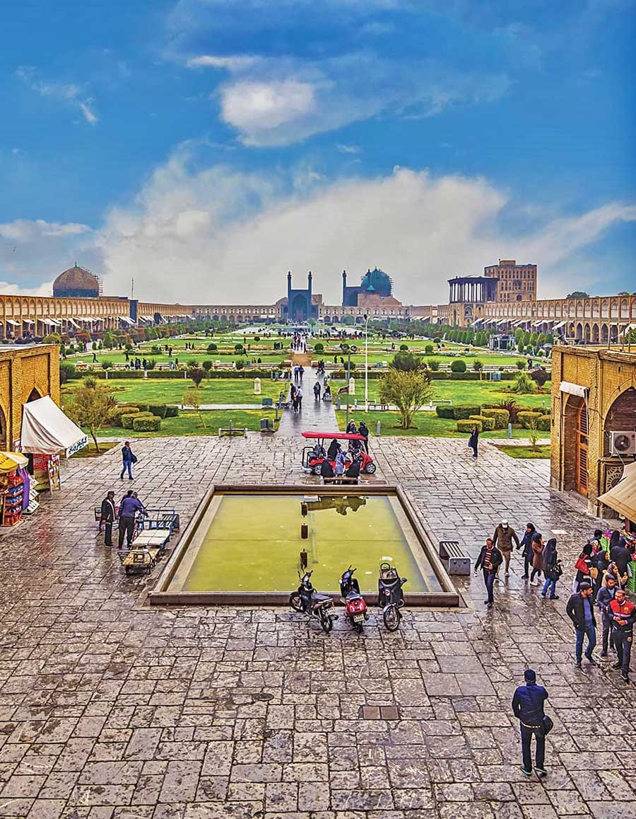
Naqsh-e Jahan Square also known as the Imam Square is a square situated at the center of Isfahan, Iran. Constructed between 1598 and 1629, it is now an important historical site, and one of UNESCO's World Heritage Sites. The square is surrounded by buildings from the Safavid era. The Shah Mosque is situated on the south side of this square. On the west side is the Ali Qapu Palace. Sheikh Lotf Allah Mosque is situated on the eastern side of this square and at the northern side Qeysarie Gate opens into the Isfahan Grand Bazaar.

